# **Practical no. 1**

**Aim:** To learn the basic concepts of core java.

## **Write a java program to display “welcome to java”.**

#### **Program:**

public class _1_a{

    public static void main(String args[]){

        System.out.println("Welcome to java");

    }

}

#### **Output:**

Welcome to java

## **Write a java program to display your name 10 times.**

#### **Program:**

public class _1_b {

    public static void main(String[] args){

        for(int i=1;i<=10;i++){

            System.out.println(i+". Jayesh");

        }

    }

}

#### **Output:**

1. Jayesh

2. Jayesh

3. Jayesh

4. Jayesh

5. Jayesh

6. Jayesh

7. Jayesh

8. Jayesh

9. Jayesh

10. Jayesh

## **Write a java program for reading data from keyboard using data input stream.**

#### **Program:**

import java.io.DataInputStream;

public class _1_c {

    public static void main(String[] args) {

        DataInputStream input = new DataInputStream(System.in);

        int intValue = 0;

        float floatValue = 0.0f;

        try {

            System.out.print("Enter an integer: ");

            intValue = Integer.parseInt(input.readLine());

            System.out.print("Enter a floating-point number: ");

            floatValue = Float.parseFloat(input.readLine());

        } catch (Exception e) {}

        System.out.println("Integer number is "+intValue);

        System.out.println("Floating point number is

        "+floatValue);

    }

}

#### **Output:**

Enter an integer: 34

Enter a floating-point number: 34.34

Integer number is 34

Floating point number is 34.34

# **Practical no. 2**

**Aim:** Write a java program to illustrate the concept of array

## **Write a java program to accept and display single dimensional array.**

#### **Program:**

public class _2_a {

    public static void main(String[] args){

        int array[];

        array = new int[5];

        System.out.print("Array elements are: ");

        for(int i=0;i<array.length;i++){

            array[i] = i+1;

            System.out.print(array[i]+" ");

        }

    }

}

#### **Output:**

Array elements are: 1 2 3 4 5

## **Write a java program to accept and display two-dimensional array.**

#### **Program:**

import java.util.Scanner;

public class _2_b {

    public static void main(String[] args){

        try(Scanner input = new Scanner(System.in)){

            System.out.print("Enter number of rows for array:

            ");

            int row = input.nextInt();

            System.out.print("Enter number of colums for array:

            ");

            int col = input.nextInt();

            int arr[][] = new int[row][col];

            System.out.println("\nCreating the

            "+(row)+"x"+(col)+" array.");

            for(int i=0; i<row;i++){

                for(int j=0;j<col;j++){

                    System.out.print("Enter element for

                    ["+i+"]["+j+"] index: ");

                    arr[i][j] = input.nextInt();

                }

            }

            System.out.println("Array elements are: ");

            for(int i =0;i<row;i++){

                for(int j=0;j<col;j++){

                    System.out.print(arr[i][j]+" ");

                }

                System.out.println();

            }

        }

    }

}

#### **Output:**

Enter number of rows for array: 4

Enter number of columns for array: 3

Creating the 4x3 array.

Enter element for [0][0] index: 1

Enter element for [0][1] index: 2

Enter element for [0][2] index: 3

Enter element for [1][0] index: 4

Enter element for [1][1] index: 5

Enter element for [1][2] index: 6

Enter element for [2][0] index: 7

Enter element for [2][1] index: 8

Enter element for [2][2] index: 9

Enter element for [3][0] index: 0

Enter element for [3][1] index: 9

Enter element for [3][2] index: 8

Array elements are:

1 2 3

4 5 6

7 8 9

0 9 8

## **Write a java program to accept value of a, b, c which are co-efficient of quadratic equation.**

#### **Program:**

import java.util.Scanner;

public class _2_c {

    public static void main(String[] args){

        int a,b,c;

        double root1, root2;

        try(Scanner input = new Scanner(System.in)){

            System.out.println("Enter values for a, b, c: ");

            a = input.nextInt();

            b = input.nextInt();

            c = input.nextInt();

        }

        double dtrmnt = (b * b) - (4 * a * c);

        if(dtrmnt>0){

            root1 = (-b + Math.sqrt(dtrmnt))/(2*a);

            root2 = (-b - Math.sqrt(dtrmnt))/(2*a);

            System.out.format("root1 = %.2f and root2 =

            %.2f",root1,root2);

        } else if(dtrmnt == 0){

            root1 = root2 = -b / (2 * a);

            System.out.format("root1 = root2 = %.2f;", root1);

        } else {

            double real = -b / (2 * a);

            double imaginary = Math.sqrt(-dtrmnt) / (2 * a);

            System.out.format("root1 = %.2f+%.2fi", real,

            imaginary);

            System.out.format("\nroot2 = %.2f-%.2fi", real,

            imaginary);

        }

    }

}

#### **Output:**

Enter values for a, b, c:

1

-2

-8

root1 = 4.00 and root2 = -2.00

# **Practical no. 3**

**Aim:** Illustrate the use of various string methods.

## **Write a java program to demonstrate the use of String methods.**

#### **Program:**

public class str {

    public static void main(String[] args){

        System.out.println("----Using the String Class----");

        char ch[]={'J','A','Y','E','S','H','

        ','V','E','R','M','A'};

        String s1 = "Jayesh Verma";

        String s2 = "Jayesh Verma";

        String s3 = new String("Jayesh R. Verma");

        String s4 = new String(ch);

        System.out.println(s1);

        System.out.println(s2);

        System.out.println(s3);

        System.out.println(s4);

        System.out.println("\n----Formatted String----");

        String name = "Jayesh";

        String sf1 = String.format("Name is %s",name);

        String sf2 = String.format("Value is %f",12039.124);

        String sf3 = String.format("Value is %20.7f",9720.3533);

        System.out.println(sf1);

        System.out.println(sf2);

        System.out.println(sf3);

        String sf4 = String.format("%d",101);

        String sf5 = String.format("%s","Jayesh Verma");

        String sf6 = String.format("%f",101.00);

        String sf7 = String.format("%x",105);

        String sf8 = String.format("%c",'J');

        System.out.println(sf4);

        System.out.println(sf5);

        System.out.println(sf6);

        System.out.println(sf7);

        System.out.println(sf8);

        System.out.println("\n----Integer Formatting----");

        String si1 = String.format("%d",101);

        String si2 = String.format("|%10d|",101);

        String si3 = String.format("|%-10d|",101);

        String si4 = String.format("|%d|",101);

        String si5 = String.format("|%010d|",101);

        System.out.println(si1);

        System.out.println(si2);

        System.out.println(si3);

        System.out.println(si4);

        System.out.println(si5);

        System.out.println("\n----Substring Demo----");

        String ss1 = "Jayesh R. Verma";

        String substr1 = ss1.substring(+2);

        System.out.println("Fetching the substring starting with

        index 2: "+substr1);

        String substr2 = ss1.substring(3, 13);

        System.out.println("Fetching the substring starting with

        index 3 and ending to index 13: "+substr2);

        System.out.println("The length of string:

        "+ss1.length());

        System.out.println("String contains(. V)?:

        "+ss1.contains(". V"));

        System.out.println("Character at index 7:

        "+ss1.charAt(7));

        String se1 = "Jayesh";

        String se2 = "jayesh";

        String se3 = "Jayesh";

        System.out.println("\nString 1: "+se1);

        System.out.println("String 2: "+se2);

        System.out.println("String 3: "+se3);

        System.out.println("\n----Case Sensetive----");

        System.out.println("String1 is equal to string2?:

        "+se1.equals(se2));

        System.out.println("String1 is equal to string3?:

        "+se1.equals(se3));

        System.out.println("\n----Case Insensetive----");

        System.out.println("String1 is equal to string2 ?:

        "+se1.equalsIgnoreCase(se2));

        System.out.println("String1 is equal to string3 ?:

        "+se1.equalsIgnoreCase(se3));

        System.out.println("\n----Concat----");

        String fn = "Jayesh";

        String ln = " Verma";

        System.out.println(fn.concat(ln));

        System.out.println("\n----Replace----");

        System.out.println("Replacin 'Jay' with 'Jiv':

        "+fn.replace("Jay", "Jiv"));

        System.out.println("Index of V in last name is

        "+ln.indexOf("V"));

        System.out.println("Surname is lower

        case"+ln.toLowerCase());

        System.out.println("Surname is upper

        case"+ln.toUpperCase());

        String strg = "    It's 1:28pm now, Are you

        tired??    ";

        System.out.println("Before trim: "+strg);

        System.out.println("After trim: "+strg.trim());

    }

}

#### **Output:**

----Using the String Class----

Jayesh Verma

Jayesh Verma

Jayesh R. Verma

JAYESH VERMA

----Formatted String----

Name is Jayesh

Value is 12039.124000

Value is 9720.3533000

101

Jayesh Verma

101.000000

69

J

----Integer Formatting----

101

| 101|

|101 |

|101|

|0000000101|

----Substring Demo----

Fetching the substring starting with index 2: yesh R. Verma

Fetching the substring starting with index 3 and ending to index 13: esh R. Ver

The length of string: 15

String contains(. V)?: true

Character at index 7: R

String 1: Jayesh

String 2: jayesh

String 3: Jayesh

----Case Sensetive----

String1 is equal to string2?: false

String1 is equal to string3?: true

----Case Insensetive----

String1 is equal to string2 ?: true

String1 is equal to string3 ?: true

----Concat----

Jayesh Verma

----Replace----

Replacin 'Jay' with 'Jiv': Jivesh

Index of V in last name is 1

Surname is lower case verma

Surname is upper case VERMA

Before trim: It's 1:28pm now, Are you tired??

After trim: It's 1:28pm now, Are you tired??

## **Write a java program to accept n strigns and sort names in ascending order.**

#### **Program:**

import java.util.Scanner;

public class sortNames {

    public static void main(String[] args) {

        try (Scanner input = new Scanner(System.in)) {

            int n;

            String temp;

            System.out.print("Enter number of names you want to

            enter: ");

            n = input.nextInt();

            input.nextLine();

            String[] names = new String[n];

            System.out.println("Enter " + n + " names: ");

            for (int i = 0; i < n; i++) {

                names[i] = input.nextLine();

            }

            for (int i = 0; i < n; i++) {

                for (int j = i + 1; j < n; j++) {

                    if (names[i].compareTo(names[j]) >= 0) {

                        temp = names[i];

                        names[i] = names[j];

                        names[j] = temp;

                    }

                }

            }

            System.out.println("\nNames in sorted order: ");

            for (int i = 0; i < n; i++) {

                System.out.println((i+1)+". "+names[i]);

            }

        }

    }

}

#### **Output:**

Enter number of names you want to enter: 4

Enter 4 names:

Jayesh

Jay

Yash

Rohan

Names in sorted order:

1. Jay

2. Jayesh

3. Rohan

4. Yash

# **Practical no. 4**

**Aim:** To learn the basic concepts of core java.

## **Write a java program to create a package MyPack with the class Balance to check the account balance of user. If it is less than 0 then show message.**

#### **Program:**

package MyPack;

class Balance{

    String name;

    double bal;

    Balance(String n, double b){

        name = n;

        bal = b;

    }

    void show(){

        if (bal < 0 )

            System.out.println("-->");

        System.out.println(name+" :Rs"+bal);

    }

}

public class AccountBalance{

    public static void main(String[] args){

        Balance[] cur = new Balance[3];

        cur[0] = new Balance("Jayesh", 123.123);

        cur[1] = new Balance("Yash", 6234.6234);

        cur[2] = new Balance("Jay", -2856.25);

        for(int i=0;i<3;i++)

            cur[i].show();

    }

}

#### **Output:**

PS F:\CS\SEM 3\P2 - Core JAVA\programs\java practicals\4th prac> javac -d . AccountBalance.java

PS F:\CS\SEM 3\P2 - Core JAVA\programs\java practicals\4th prac> java MyPack.AccountBalance

Jayesh :Rs123.123

Yash :Rs6234.6234

-->

Jay :Rs-2856.25

#### **Explanation :**

1. javac -d . Program_name.java

-d &lt;directory&gt; Specify where to place generated class files

The above command states that put Program_name.class in the current

directory. Hence package MyPack will be automatically created with 2 class

files AccountBalance.class and Balance.class. MyPack will be placed in

jdk1.6\bin directory.

## **Write a java program to create a package and display a message.**

#### **Program:**

package SecondPack;

class pack{

    public static void main(String[] args){

        System.out.println("This is an second package!!!");

    }

}

#### **Output:**

PS F:\CS\SEM 3\P2 - Core JAVA\programs\java practicals\4th prac> javac -d . pack.java

PS F:\CS\SEM 3\P2 - Core JAVA\programs\java practicals\4th prac> java SecondPack.pack

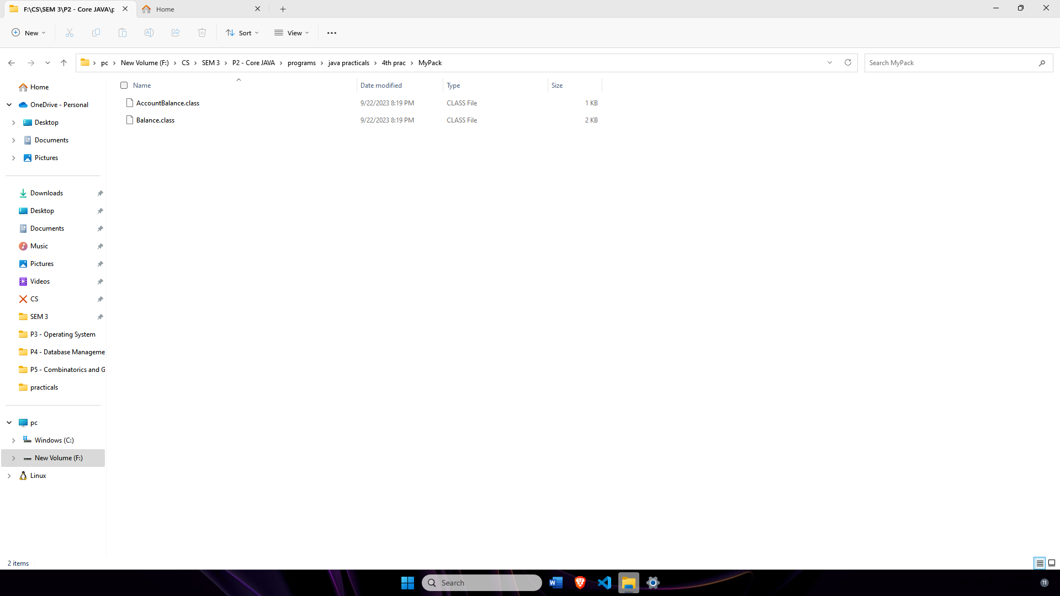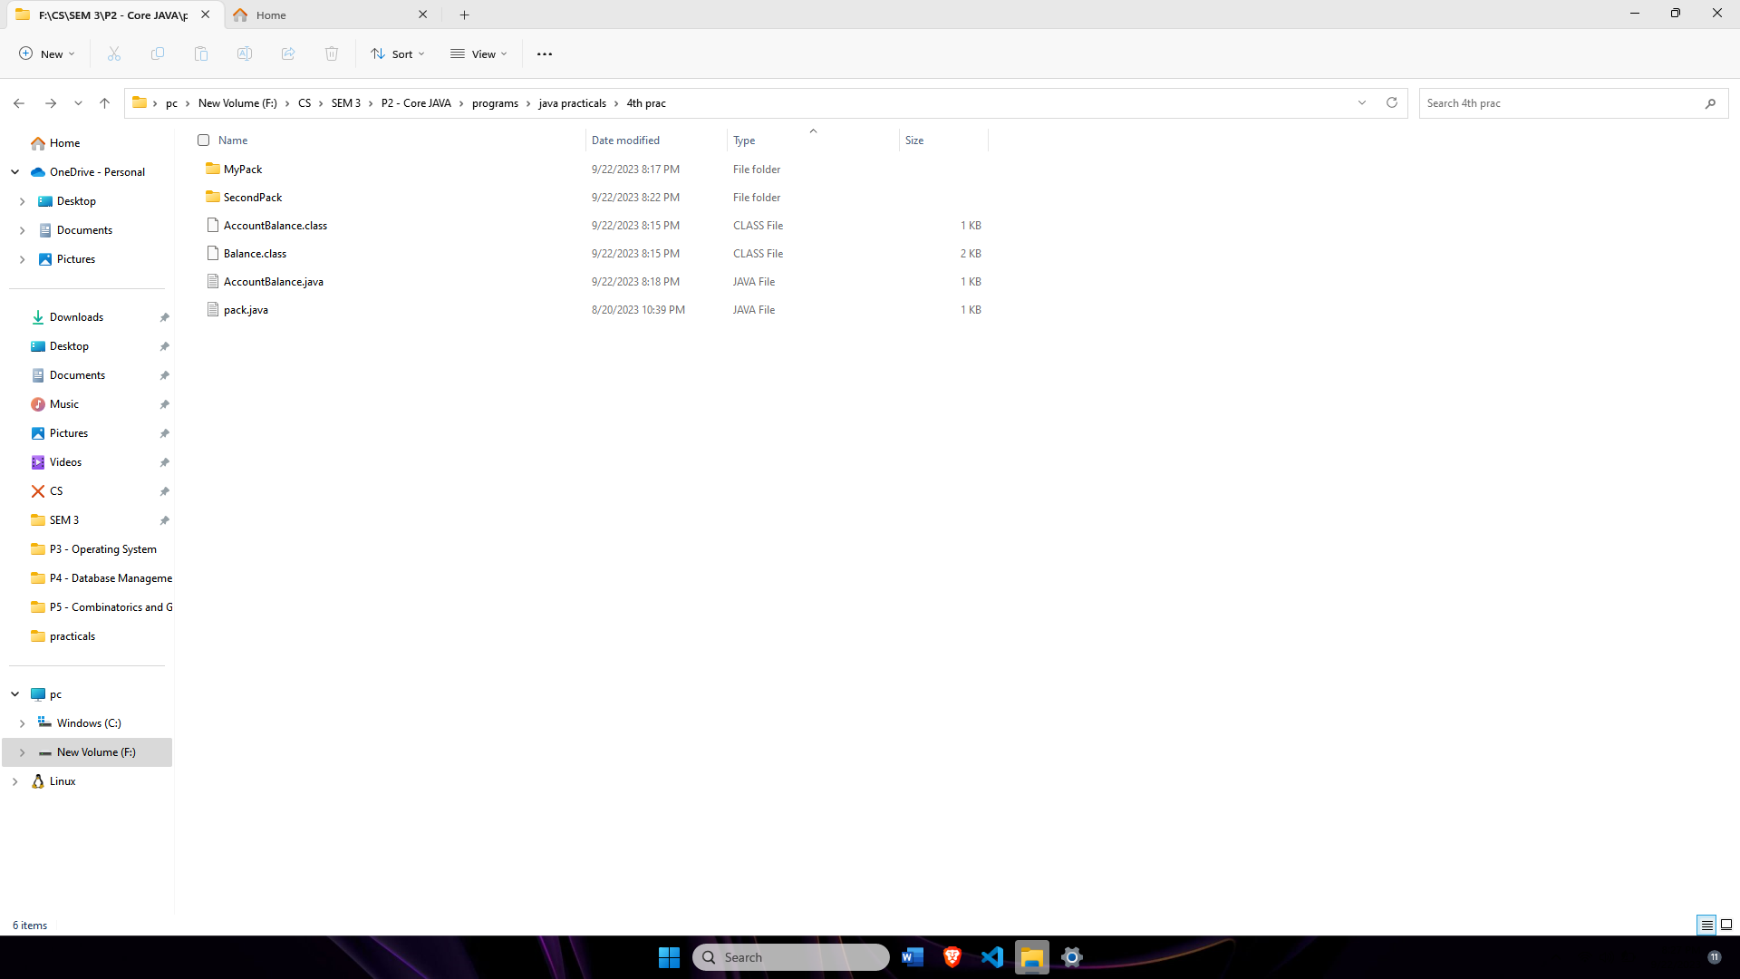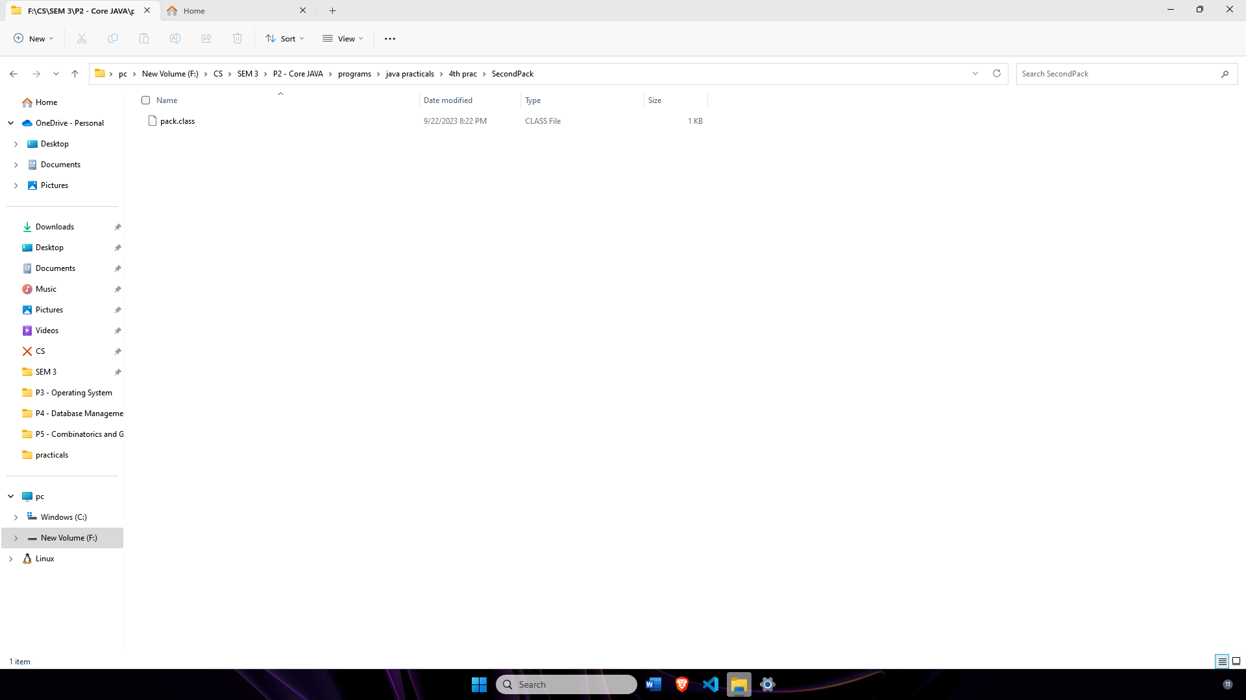This is an second package!!!